

Characteristic

* Low power processor : STM8L051 (1)
* communication interface：SPI、UART (2)
* electrical level：3.3V TTL
* Frequency range：410MHz-470MHz
* Center frequency：433MHz
* Maximum power：19.26dBm (3)
* Sensitivity：-148dBm
* Reference transmission distance :10KM (4)
* Modulation mode: FSK,GFSK,LoRa,OOK
* Package: Stamp hole with shield
* Size: 14mm x 17 mm x 2.5 mm
* Production process：Lead free
* Temperature：-40 ～ +85 ℃
* Humidity: 10% ～ 90% Relative humidity, no condensation
* Storage temperature：-40 ～ +125℃

Document state

* V0.6

Remarks

* 1：Only HIMO-01M has the characteristics
* 2：Only HIMO-01M provides the UART interface
* 3：The official parameter be matching, the RF output is between 18.5 and 19.5. The RF output of HIMO-01 is 19.26dBm
* 4：Under excellent conditions 10KM

01M work mode

* Broadcast emission mode
* Single point to Single point
* Single point to multipoint（65535 addresses can be configured to facilitate networking）

01M Extra characteristics

* CMD UART：115200，8N1
* CMD interface : AT CMD with UART
* Direct transmission mode
* Address filtering function

Power

* Power supply: 2.8V - 3.6V（proposal 3.3V）
* Maximum sustained emission current：93mA
* Continuous receive mode current：14mA
* IDLE mode current：0.75mA

Application

* Automatic meter reading
* Family and building automation
* Wireless alarm and security system
* Industrial monitoring
* Remote sensor communication

HIMO-01(M)

HIMO series modules are fabricated based on LoRa (SX1278) spread spectrum chip，HIMO-01 is a single SX1278 module and HIMO-01M is SX1278+MCU Binding body，The two models are compatible with PIN-to-PIN. HIMO series wireless module can provide remote and low-power wireless communication function for equipment.

Size（Unit: mm）

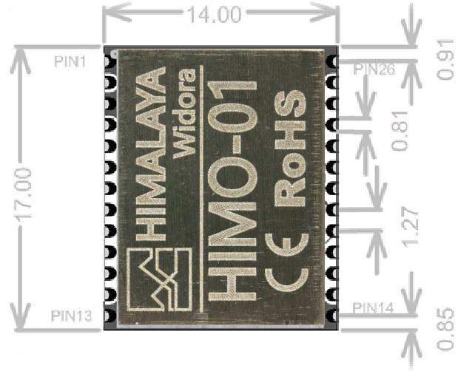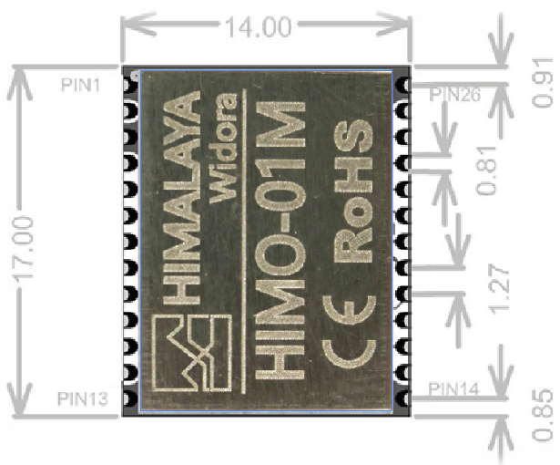

Pin List

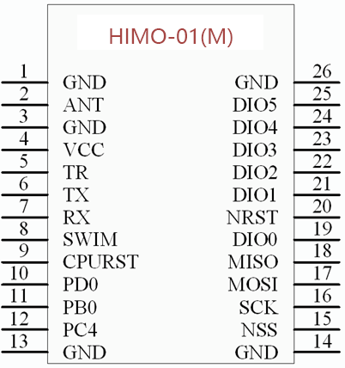

|  |  |  |
| --- | --- | --- |
| Pin | Identification | Function |
| 1 | GND | Power ground |
| 2 | ANT | RF output and input |
| 3 | GND | Power ground |
| 4 | VCC | Power supply |
| 5 | TR | 1278 Transceiver switching (suspended) |
| 6 | TX | UART data output |
| 7 | RX | UART data intput |
| 8 | SWIM | STM8 debug port |
| 9 | CPURST | STM8 reset（Low effective） |
| 10 | PD0 | GPIO D0 |
| 11 | PB0 | GPIO B0 |
| 12 | PC4 | GPIO C4 |
| 13 | GND | Power ground |
| 14 | GND | Power ground |
| 15 | NSS | 1278 SPI CS |
| 16 | SCK | 1278 SPI clock |
| 17 | MOSI | 1278 SPI data input |
| 18 | MISO | 1278 SPI data output |
| 19 | DIO0 | 1278 IO0 |
| 20 | NRST | 1278 reset（Low effective） |
| 21 | DIO1 | 1278 IO1 |
| 22 | DIO2 | 1278 IO2 |
| 23 | DIO3 | 1278 IO3 |
| 24 | DIO4 | 1278 IO4 |
| 25 | DIO5 | 1278 IO5 |
| 26 | GND | Power ground |

AT CMD

|  |  |  |  |
| --- | --- | --- | --- |
| CMD | CMD format | Reply data format | Explain |
| TEST | AT\r\n | AT,OK\r\n | Test cmd |
| RST | AT+RST\r\n | AT,OK\r\n | Module reset control |
| Version read | AT+VER\r\n | AT,V0.3,OK\r\n | Version V0.4,x.x format |
| Idle mode | AT+IDLE\r\n | AT,OK\r\n | STM8 work and SX1278 sleep，module defaults work mode after power on |
| Sleep mode | AT+SLEEP=1\r\n | AT,OK\r\n | Sleep mode,STM8 and SX1278 all entry sleep mode,only can be wakeup with PC4 Falling edge |
| Exit sleep mode |  | AT,WakeUp\r\n | PC4 Falling edge wakeup MCU,then MCU send “AT,WakeUp\r\n” on Tx pin |
| Entry Rx mode | AT+RX\r\n | AT,OK\r\n | Entry Rx mode,Receive mode is asynchronous receive.  ●If it is work on single rx mode, the receiver is automatically restored to the idle mode after completion of the reception .  ●If it is a continuous receive mode, it will always be in the receiving state. |
| Receive data  (asynchronous) |  | LR,XXXX,XX,ASFASDFASFD | XXXX is source address. The expression is HEX, such as FFCA.  XX is data length, the expression is HEX, The range is (0x01~0xFB), such as 5A, representing 90 bytes.  ASFASDFASFD is arbitrary data, not limited to characters |
| Receive data Timeout  (asynchronous) |  | AT,TimeOut\r\n | Only work on signal receive mode |
| Query RSSI value | AT+RSSI?\r\n | AT,-XXX,OK\r\n | Expression of HEX, such as -63dB express with:”AT,-063,OK\r\n” |
| Set module address | AT+ADDR=XXXX\r\n | AT,OK\r\n | Expression of HEX. Range from 0000 to FFFF.  FFFF is special address. If a module sets its own address to FFFF, then it can monitor all communication data at the same frequency. |
| Read module address | AT+ADDR? \r\n | AT,XXXX,OK\r\n | Expression of HEX，Range from 0000 to FFFF.  For example D5AA: represents the address value of 0xD5AA. |
| Set target address | AT+DEST=FF5A\r\n | AT,OK\r\n | expression is HEX，Range from 0000 to FFFF.  FFFF is a special address. If a module sets the target address to FFFF, the module is in a broadcast state. |
| Read target address | AT+DEST? \r\n | AT,XXXX,OK\r\n | expression is HEX，Range from 0000 to FFFF.  For example, FFAA: represents the address value of 0Xffaa. |
| Set address filter enable | AT+ADDREN=1 \r\n | AT ,OK\r\n | 1:enable  0:disable(default)  This module uses the soft address protocol. If the user closes the soft address filtering, the address rule will be invalid. All modules can communicate freely. |
| Read address filter enable | AT+ADDREN? \r\n | AT ,X,OK\r\n | X:  1:enable  0:disable |
| Config data | AT+CFG=433000000,20,6,10,1,1,0,0,0,0,3000,8,4\r\n | OK\r\n | RF Frequency: 433000000  Power: 20  Signal Bw: 6  Spreading Factor: 10  Error Coding: 1  CRC: 1  Implicit Header On: 0  Rx Single On : 0  Frequency Hop On: 0  Hop Period: 0  Rx Packet Timeout: 3000  Payload Length: 8  Preamble Length: 4  More in 《Parameter configuration command table》. |
| Save command | AT+SAVE\r\n | AT,OK\r\n | Configuration parameters, their own address and target address will be saved to EEPROM. It will be the default parameters on boot. Because of the inherent nature of EEPROM, do not call frequently. |
| Send data command | AT+SEND=XX\r\n | AT,OK\r\n  AT,SENDING\r\n  AT,SENDED\r\n | Parameters: XX(Decimal data) represents the length of the transmitted data, in the range of 1-250.  For example, to transmit 25 bytes of data, send AT+SEND=25\r\n to module, then will back “AT,OK\r\n”, At this point, the user can transfer 25 bytes of arbitrary data through the serial port. More data will be discarded. After the module receives 25 bytes,the module will back “AT,SENDING\r\n” to user. Indicates that the module enters the sending State. At this point, the user needs to wait for the module to reply “AT+SENDED\r\n” to indicate that the data is sent to complete. |
| Enter the direct transmission | AT+TSP\r\n | AT,OK\r\n | The device will enter the transfer mode, after which all serial data will be sent directly. Note: After sending, the module will not prompt any information! Users need to evaluate the time needed to complete the delay between two sending intervals. If the module is sending the last data and receiving the data that the user requests to send, it will report "AT, busy..." Mistake |
| Exit the direct transmission | +++ | AT,OK\r\n  AT,busy...\r\n | The device successfully exits the direct transmission mode and enters the standard AT command.  The device is busy sending data. Please try again later.  Users must ensure that the module sends the “+++” command in the idle state (without sending data) in order to exit the transmission mode correctly, so it is recommended that users add a suitable delay before sending “+++”. |

Parameter configuration command table

| Parameter name | describe | Range | Example |
| --- | --- | --- | --- |
| carrier frequency | The carrier frequency of the module.  Represented by 9 decimal characters | 410MHz-470MHz | 433000000 |
| Power | Transmit power.  Represented by 2 decimal characters | 5dBm-20dBm | 20 |
| Modulation bandwidth | The bandwidth of the channel is occupied by the transmitter.  The larger the bandwidth is, the faster the data transmission will be. But meanwhile the sensitivity is becoming lower.  In the configuration command, only the code name of the bandwidth is used. | 7.8K-500K,Code and bandwidth are as follows:  0: 7.8KHz  1: 10.4KHz  2: 15.6KHz  3: 20.8KHz  4: 31.2KHz  5: 41.6KHz  6: 62.5KHz  7: 125KHz  8: 250KHz  9: 500KHz | 6 |
| Spreading Factor | The key factor of spread spectrum communication is that the larger the spread factor.  The slower the data transmission is, the higher the sensitivity will be.  In the configuration command, the spreading factor code name is used only. | 64-4096,Code and spread factor is as follows:  6: 64  7: 128  8: 256  9: 512  10: 1024  11: 2048  12: 4096 | 10 |
| Error Coding | The key parameters of the spread spectrum communication.  The configuration command only uses the code name of error correction code. | 4/5-4/8，Code and Error Coding is as follows：  1: 4/5  2: 4/6  3: 4/7  4: 4/8 | 1 |
| CRC | Payload data CRC check | 0: close  1: open | 1 |
| Implicit Header On |  | 0: explicit  1: Implicit | 0 |
| Rx Single On | Receive mode setting | 0: continue  1: single | 0 |
| Frequency Hop On |  | 0: not support  1: support | 0 |
| Hop Period | Time interval of each frequency hopping | reserve | 0 |
| Rx Packet Timeout | Receive data timeout. In a single receive mode, when more than this time has not received the data module will report timeout error, and automatically enter the SLEEP mode, decimal representation, the unit is milliseconds | 1-65535 | 3000 |
| Payload Length | Payload length is represented by decimal notation.  Effect：In implicit header mode, specifies the length of the data sent and received by the module (length = actual user data length +4). Invalid under explicit header. | 5-255 | 8 |
| Preamble Length | The preamble length is represented by decimal notation | 4-65535 | 4 |

ERROR CMD

|  |  |
| --- | --- |
| Error cmd | explain |
| ERR:CMD\r\n | Command error, send command format error. |
| ERR:CPU_BUSY\r\n | CPU busy error. |
| ERR:RF_BUSY\r\n | SX1278 busy error，When the user sends data, SX1278 not complete the last sending task and returns this error. |
| ERR:SYMBLE\r\n | Only after the command can identify “=” or “?”, if a command does not support the identifier or the user sends the wrong identifier, it will return this error. |
| ERR:PARA\r\n | The parameter is wrong. If the user enters the wrong parameter after the identifier, the error is returned. |
| AT,busy…\r\n | In the direct transmission mode, if the module is in the wireless transmission state and the user tries to send data through the serial port again, this error will occur. |

User guide（HIMO-01M）

This module automatically loads the parameters saved at the last time after power on, and directly enters the transmission mode. Users can send and receive data directly through the serial port. If the user wants to change the configuration parameters, you needs to send "+++" to exit the transmission mode, change the parameters after entering the AT command mode correctly, and save them. After that, users can operate in three ways .

1. Reset module by reset command (AT+RST\r\\n). After the module reset successfully, it can send and receive data directly.

2. Exit the transmission mode, the module will automatically enter the receiving state and can receive data asynchronously. Users can communicate directly in AT command mode, and send AT+RX\r\n to the receiving state; send AT+SEND=10\r\n to enter the sending state, and then send 10 user data (data number should corresponding to the previous command); send AT+IDL. E\r\n, SX1278 enters the idle state, and the continuous current will be reduced to 0.7mA.

3. Direct access to the transmission mode through AT+TSP\r\n command. After entering the transmission mode, if the module is in IDLE mode, it will automatically enter the receiving mode.

Address filtering function is a feature of this module. It can switch flexibly. In the case of closing, all modules can communicate as long as the wireless parameters are configured the same. It can also be compatible with other brands of transmission module. If the address filtering function is turned on, the module will automatically shield messages that are not sent to itself, even in the transmission module. It can also achieve address filtering, filter out data that are not concerned with, and reduce the difficulty of developing multi-module communication information that users need to filter other module information.

## Hardware cable connection

**1. Connecting module at computer end:**

Users need to connect RX and TX of USB to serial module, RX and TX of TX cross-link module, and GND and VCC. They must ensure that VCC is 3.3V voltage, and if the voltage is 5V, it will burn the module.

**2. MCU connection module:**

Users need to cross connect RX and TX of MCU serial port and module. Then connect GND and VCC, make sure that VCC is 3.3V voltage, if the voltage is 5V, it will burn the module. In addition, the user can connect the CPU_RST pin to the IO of the MCU, and the user can control the module to reset forcibly. Connect "PC4" to IO, which enables users to detect whether new data is received when ACK commands are enabled. PC4 can also be connected to the LED as a receiving indicator.

## Software testing (through PC test module)

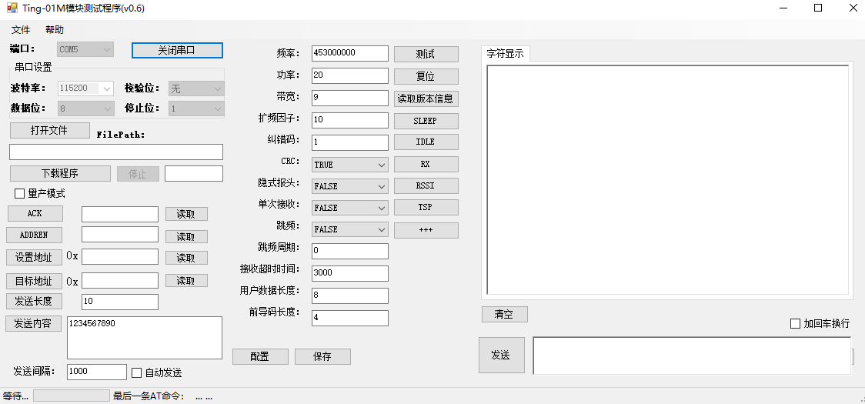

**Sender**: Open the Ting_Test program and choose the right serial port to open. If you need to modify the configuration, click "++" to exit the transmission mode, update the settings and save them, and click "Reset" or "TSP" to enter the transmission mode. You can fill in the user data in the blank area in the lower right corner and click "Send" to send the data out. Users must ensure that when they click on Send again, the Lora module has successfully sent the last data, otherwise they will return "AT, busy..." Mistake. The data received by the user is automatically displayed in the receiving area.

**Receiver**: Open the Ting_Test program and choose the right serial port to open. If you need to modify the configuration, click "++" to exit the transmission mode, update the settings and save them, and click "Reset" or "TSP" to enter the transmission mode. The user will receive the data sent by the sender and display the receiving area, even if the user can receive the data in the non-transparent mode.

**Be careful:**

1. If the user exits the transmission mode, the LoRa state will automatically enter the receiving state, so even if the user is not in the transmission mode, he can receive the data from the sender. If you do not want to receive data, set the module to IDLE mode.

2. In order to receive data correctly, users must ensure that the wireless parameters at both ends are identical and set appropriate address rules.

3. The sender closes the ADDREN and the receiver opens the ADDREN. In this case, if the receiver's address is 0XFFFF or the sender's target address is 0XFFFFFF, the data without the address protocol will be parsed according to the data format with the address protocol, and 0XFFFFFF means that no address data can be filtered. So the source address and data length will be resolved incorrectly (resolving the first 1 or 2 bytes of user's payload data to source address, resolving 3 or 4 bytes to target address, data length or user's data length, the output result will discard the first 4 bytes, and adding 4 uncertain data after user's data ends) 。

Example:

Send: "1234567890"

Receiver sends the frame data to host through serial port after receiving "LR, 3132, 0A, 567890xxxx"

31: ASCII code 31 representing the sender's first byte'1';

32: ASCII code 32 representing the sender's second byte'2';

0A: Represents the total data length of the sender.

Xxxx: Because user data 1234 is mistaken for the source address and destination address, the first four bytes are skipped when the module is forwarded out, so there will be four uncertain XXXX data later.

If both the source address and the destination address of the sender and the receiver are not 0XFFFFFF broadcast addresses, the data will not be output if the address matching is not possible.

4. The sender opens the ADDREN and the receiver closes the ADDREN. If the receiver's address is 0XFFFF or the sender's target address is 0XFFFFFFFF, in this case, the receiver will receive more than four bytes of data, which is the source address and destination address information of the sender, and then the user data.

5. Users can try command mode, transmission mode, address enablement and any combination of various address configurations at the upper level to test the desired results.

6. Under the control of single-chip computer, the idea is the same as that of the host computer.

## About conflict

LoRa module is a half-duplex mode. It is better for the two modules to work in a question-and-answer state, similar to the 485 bus state, so as to ensure that the data will not be lost. Otherwise, the conflict will not ensure that the data can be sent out correctly. And the module may not be able to report this error. If users use "multi-active sending mode" to produce this conflict, it is inevitable that users need to ensure the normal communication of data through software protocols.

If LoRa module has been used locally and occupies a certain frequency point, it will also cause interference to the module. In this way, users need to switch frequency points to avoid unnecessary interference

## Update Firmware

Select the corresponding bin file by "Open File". If the module works in the transfer mode, click the +++ button to make the module exit the transfer mode correctly, then click the "download program" button, wait for the next progress bar to complete 100% of the update firmware program, the module automatically resets and loads the last saved parameters (update firmware will not clear the previous settings), and then proceed. Penetration mode.

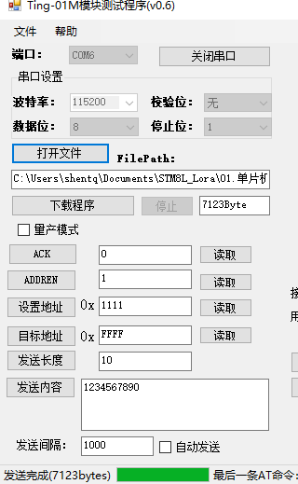

**Latest information:**

**https://github.com/eboxmaker/STM8L_Lora**